**Task 1: Running Python Script and various expressions in an interactive interpreter**

**Aim:**

To run python Script and various expressions in an interactive interpreter

1. **Create a python program to enter two numbers and then performs and displays the results of the following operations: addition, subtraction, multiplication, and division.**

**Algorithm:**

1.Start.

2.Get the two numbers and store it in variable x and y.

3.For Addition do ; x+y and print it.

4.For Subtraction do ; x-y and print it.

5.For Multiplication do ; x*y and print it.

6.For Division do; x/y and print it.

7.Stop

**Program:**

x =int(input("Enter the First number:"))

y =int(input("Enter the Second number:"))

add = x + y

sub = x - y

pro = x * y

div = x / y

print("Addition:",add)

print("Subtraction :",sub)

print("Multiplication:",pro)

print("Division:",div)

**Output:**

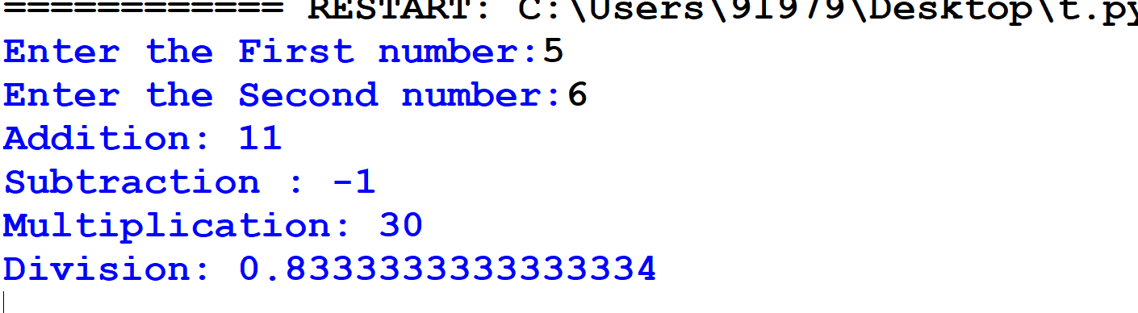

1. **Create a python program to enter two numbers and then performs and displays the results of the following relational expression : >, <, ==, !=, >=, <=**

**Algorithm:**

1.Start

2.Get the the input from the user and store it in a,b&c.

3.Perform the relational operations( i.e, >,<.=,==,!=,>=,<=).

4.Print the results.

5.Stop.

**Program:**

# Initializing the value of a, b, and c

a = int(input("Enter the First number: "))

b = int(input("Enter the Second number: "))

c = int(input("Enter the Third number: "))

# Using relational operators

print(a, ">", b, "is", a > b)

print(a, "<", b, "is", a < b)

print(c, "==", a, "is", c == a)

print(c, "!=", b, "is", c != b)

print(a, ">=", b, "is", a >= b)

print(b, "<=", a, "is", b <= a)

**Output:**

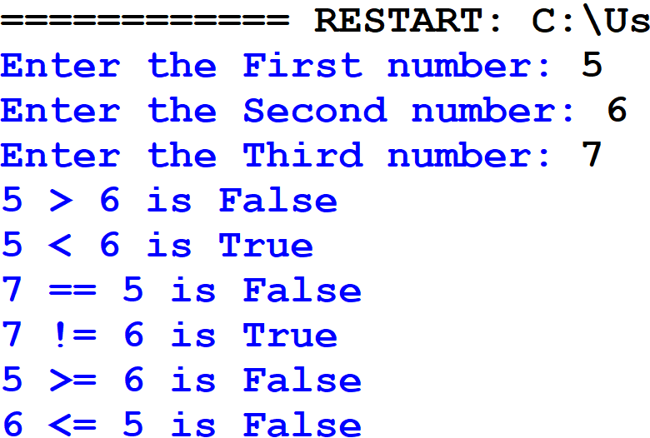

1. **Create a python program to enter three numbers and then performs and displays the results of the following Logical operations: and, or, not.**

**Algorithm:**

1.Start.

2.Get the input from the user.

3.Perform the logical operations on the inputs.

4.Print the results.

5.Stop.

**Program:**

# Taking three numbers as input

a = int(input("Enter the First number: "))

b = int(input("Enter the Second number: "))

c = int(input("Enter the Third number: "))

# Performing logical operations

print("\nLogical Operations Results:")

print((a > b) and (b > c))

print((a > b) or (b > c))

print(not(a > b))

print(not(b > c))

**Output**

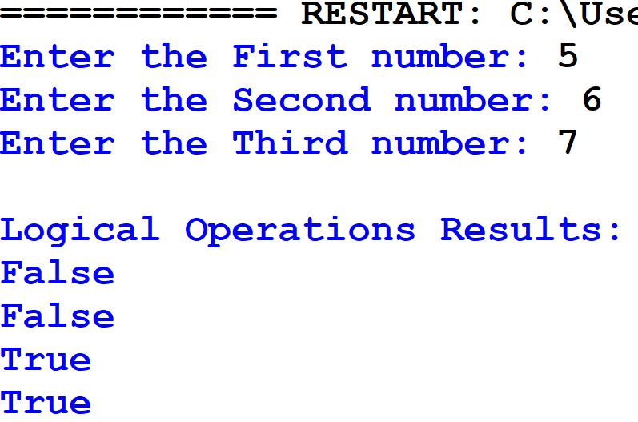

**Result**

Thus, the python program to run Python Script and various expressions in an interactive interpreter was don successfully and the output was verified.